**Database Schema**

**Databse Name -**

--Create Database TaxDatabase

IF NOT EXISTS(SELECT * FROM sys.databases WHERE name = 'TaxDatabase')

BEGIN

CREATE DATABASE [TaxDatabase]

END

GO

**Dbo.MunicipalityDetails**

USE [TaxDatabase]

GO

IF NOT EXISTS (SELECT * FROM sys.objects

WHERE object_id = OBJECT_ID(N'[dbo].[MunicipalityTax]') AND type in (N'U'))

BEGIN

Create Table MunicipalityDetails

(

MunicipalityId Int Identity(1,1) Primary Key,

MunicipalityName Varchar(100) Not Null

)

END

GO

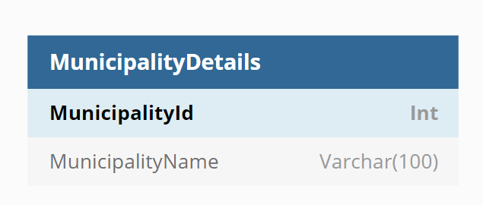

**Dbo. MunicipalityTax**

IF NOT EXISTS (SELECT * FROM sys.objects

WHERE object_id = OBJECT_ID(N'[dbo].[MunicipalityTax]') AND type in (N'U'))

BEGIN

CREATE TABLE dbo.MunicipalityTax (

ScheduledTaxId Int Identity(1,1) Primary Key,

MunicipalityId Int,

MunicipalityName Varchar(50),

TaxType Varchar(50),

TaxStartDate DateTime,

TaxEndDate DateTime,

TaxAmount float

)

END

